Academy Center of the Arts
Supply List for Zorn Palette Portrait Workshop
Kenneth Weinfurtner, Instructor
Paint Oil or Acrylic paint:
cadmium red, cadmium red light or genuine Chinese vermillion.
iron oxide yellow, yellow ochre or Naples yellow.
ivory black
titanium white.
Painting Surfaces
any surface is fine for painting as long as it is primed.
size should be 11” x 14”, 14" x 18", 16” x 20”.
Birch panels, canvas panels, primed masonite, stretched canvas.
Prime your surface with gray in a value 3 or 4 according to the 7 value scale.
Save your good paints and use a cheap acrylic house paint. It can be toned by adding your black paint to white.
Brushes
Oil paint brushes: Hog Bristle Brushes, flat, filbert, round. Bring many if using oils.
Acrylic paint brushes: Synthetic, flat, filbert, round.
Palette
any smooth surface, 12 x 16" or bigger.
many like to use palette paper on Masonite or cardboard.
Sources:
The Art Box, 12th St. at Grace St. Take this paper and receive a discount.
Dick Blick https://www.dickblick.com/
Zorn Palette Color Chart
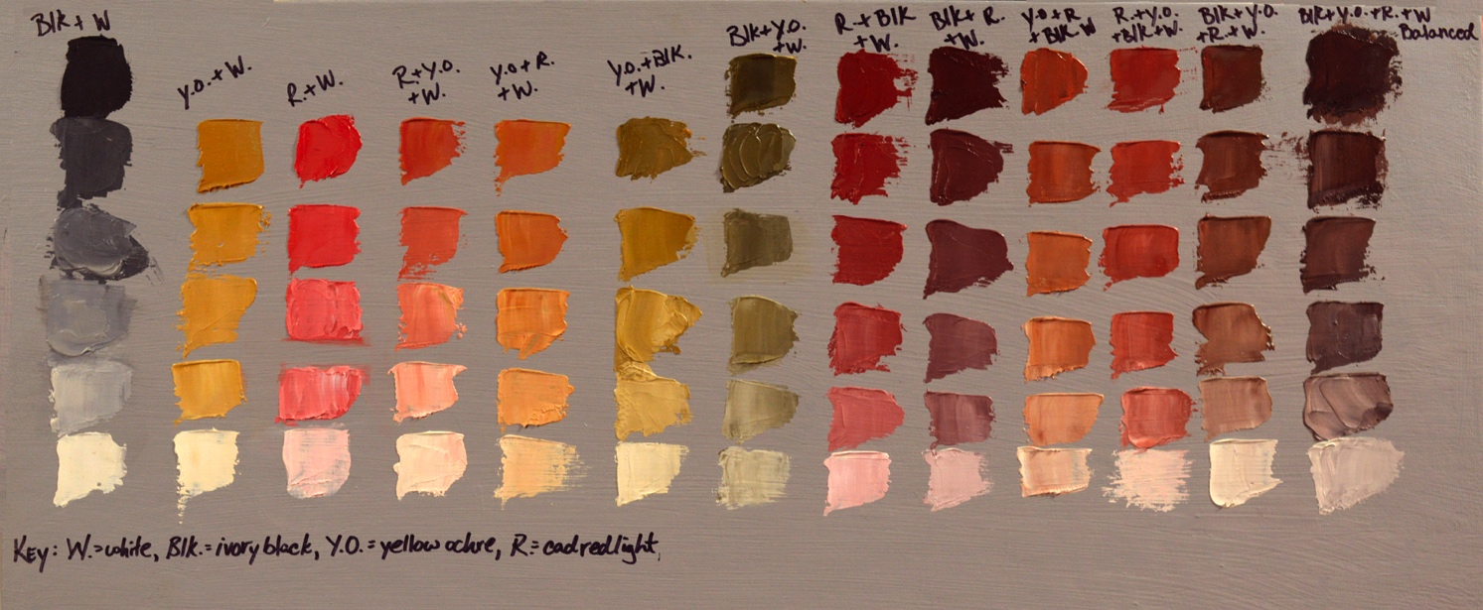
Make each color string the darkest it is in its natural state – Blk is value 7, YO is value 4 – then add white to lighten – as light as it can be and retain its color identity. Make each string 5 or 6 values. When mixing two or more colors make one dominant (eg. R+YO vs. YO+R). The final string is a balanced (totally neutral) mixture.
Use a palette knife to keep colors clean. It’s easiest to mix the darkest color, then the lightest color, then the colors in between. Questions? please call or write.

